Animal Adoption Service

User Stories:

* As a Health Care Officer, I want to query which animals have not been neutered so I can book an appointment with the vets.  
  Select * from exam1.animals where neutered='N' and AnimalID not in(

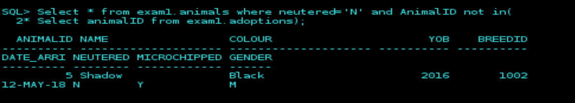Select animalID from exam1.adoptions);

* As a Social Media Consultant, I want to query which animals have been there the longest, so I can create a campaign online to get them homed quickly.  
  Select * from exam1.animals where animalID not in(

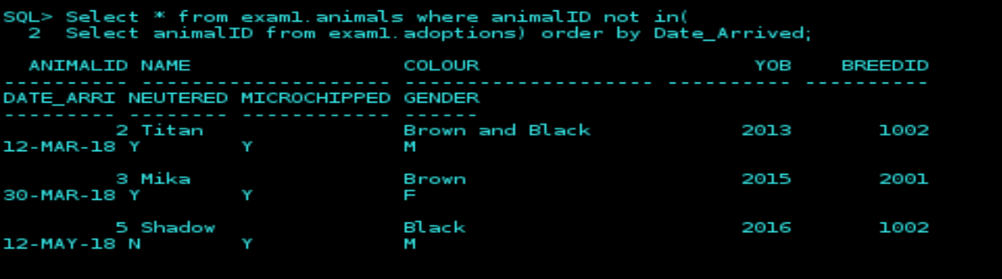Select animalID from exam1.adoptions) order by Date_Arrived;

* As a Receptionist, I want to query animals by specific criteria to help direct customers to the animals they wish to adopt  
  select * from exam1.animals where

BreedID in(select BreedID from exam1.Breed where

SpeciesID in(Select SpeciesID from exam1.Species where Speciesname='&Species'))

and BreedID=(Select BreedID from exam1.breed where BreedName='&Breed')

and

AnimalID not in (select AnimalID from exam1.adoptions);

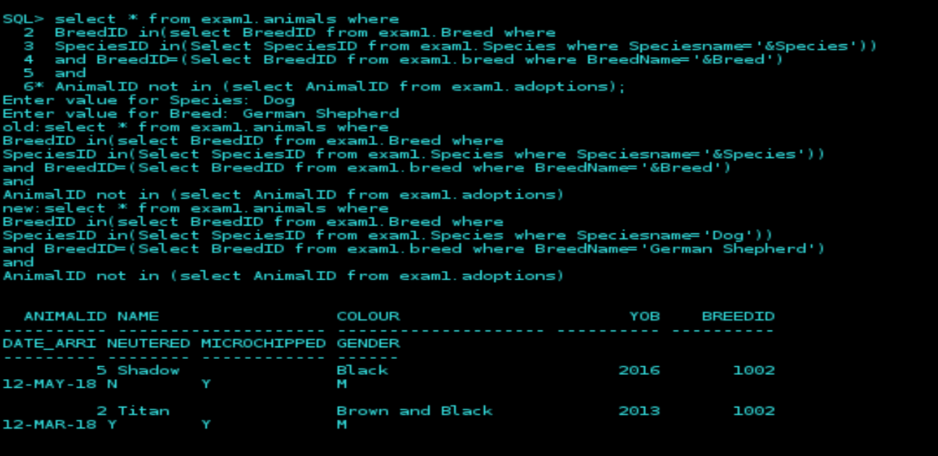

* As a Health Care Officer, I want to be able to see animals vaccination records.  
  Select * from exam1.vaccinations where

animalID=(select AnimalId from exam1.animals where Name='&Name' and BreedID=

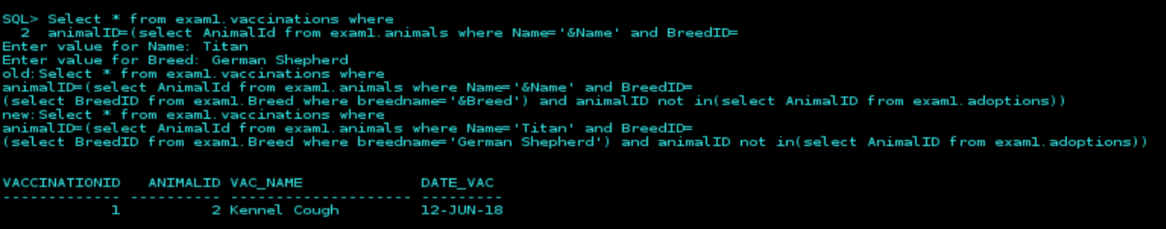(select BreedID from exam1.Breed where breedname='&Breed') and animalID not in(select AnimalID from exam1.adoptions));

* As a Health Care Officer, I want to query which animals have not been microchipped  
  Select * from exam1.animals where microchipped='Y' and AnimalID not in(

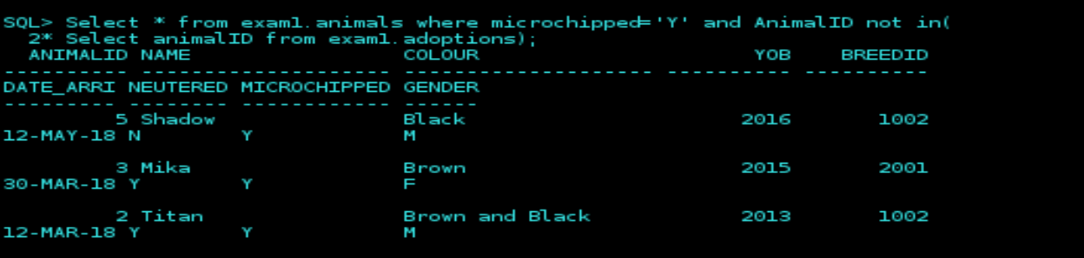Select animalID from exam1.adoptions);

* As a Welfare Officer, I want to query customer phone numbers so that I can check up on them at intervals after adoption.  
  select Customer.Name, Surname, Home_Phone, Mobile, adoptions.Date_adopted,   
   adoptions.AnimalID from exam1.customer, exam1.adoptions where customer.customerID in(select

customerID from exam1.Adoptions) and

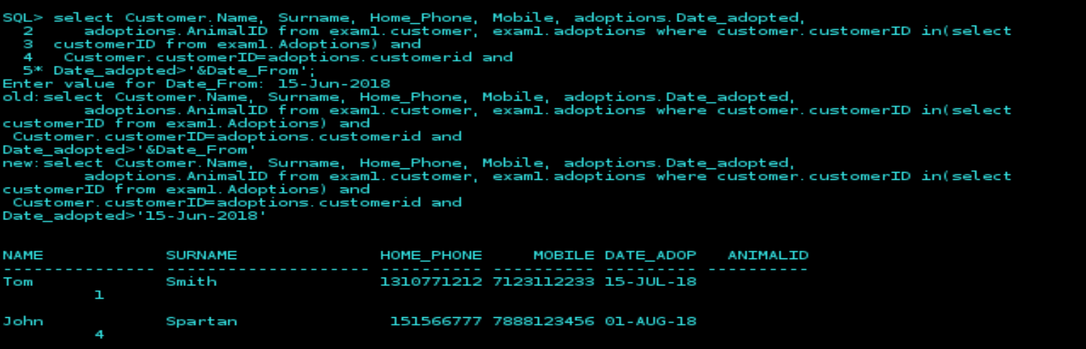 Customer.customerID=adoptions.customerid and

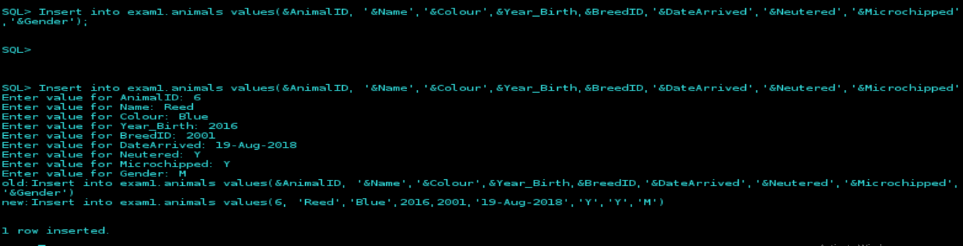Date_adopted>'&Date_From';  
  
As a Welfare Officer, I want to be able to add new animals to the database.  
Insert into exam1.animals values(&AnimalID, ‘&Name’,’&Colour’,&Year_Birth,&BreedID,’&DateArrived’,’&Neutered’,’&Microchipped’,’&Gender’);

* As an Manager, I want all animal records deleted to be backed up so mistakes are covered.

Tables

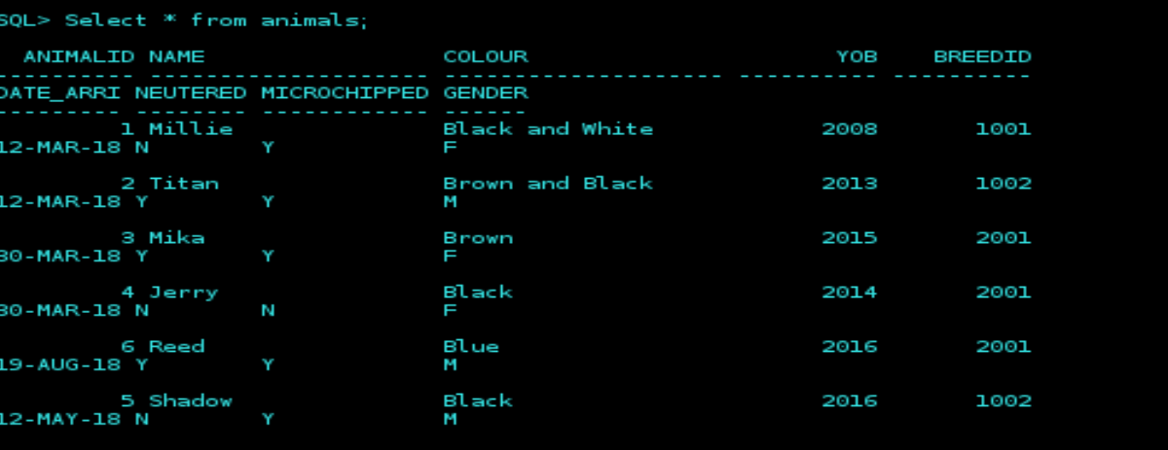

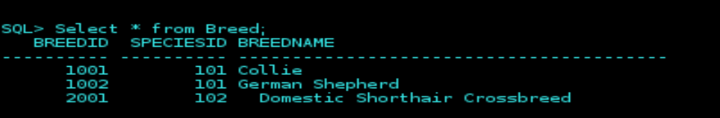

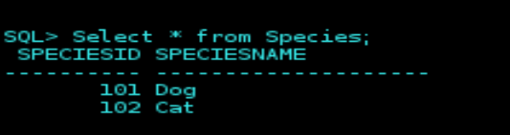

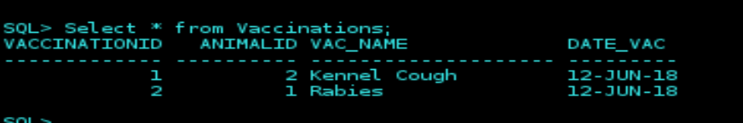

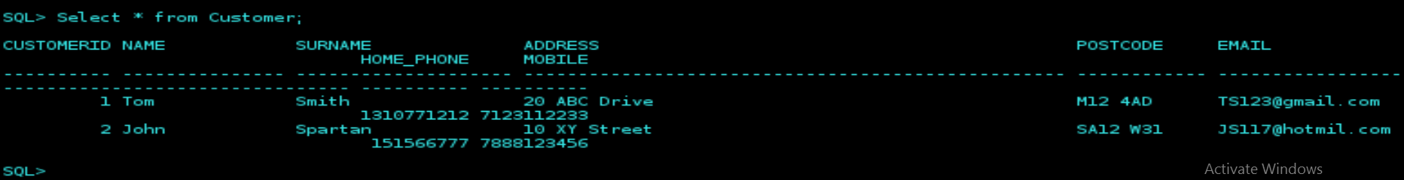

Users:

Health Care – HCO / HCO – All to All

Welfare off - WO / WO – Select to Animals, Breed, Species, Customer, Adoptions, Vaccinations

Receptionist – Rec / Rec – Select to all. Insert,update,delete to customer

Social Media Consultant – SMC / SMC – Select to animals, Breed, Species